RoomAQuestion 1
Q 1 / Breast DCIS (Reviewed by KC)
Stem:
55y postmenopausal female with no past medical or surgical history is referred to the office for calcifications seen in the upper outer quadrant of the left breast on annual screening mammogram that weren’t appreciated on the mammogram the year prior. She denies any changes in her breasts or axillae.
Family history is negative for breast or gynecologic malignancies.
Her physical exam is unremarkable.

What is your Differential Dx?
- DCIS
- LCIS
- Invasive breast cancer
- Atypical ductal or lobular hyperplasia
- Fibrocystic changes
- Fat necrosis
Additional Workup or Studies?
- Diagnostic mammogram :Fine linear branching calcifications located near the chest wall in the upper, outer quadrant of the left breast; the calcifications appear focal and do not appear to be multicentric
- 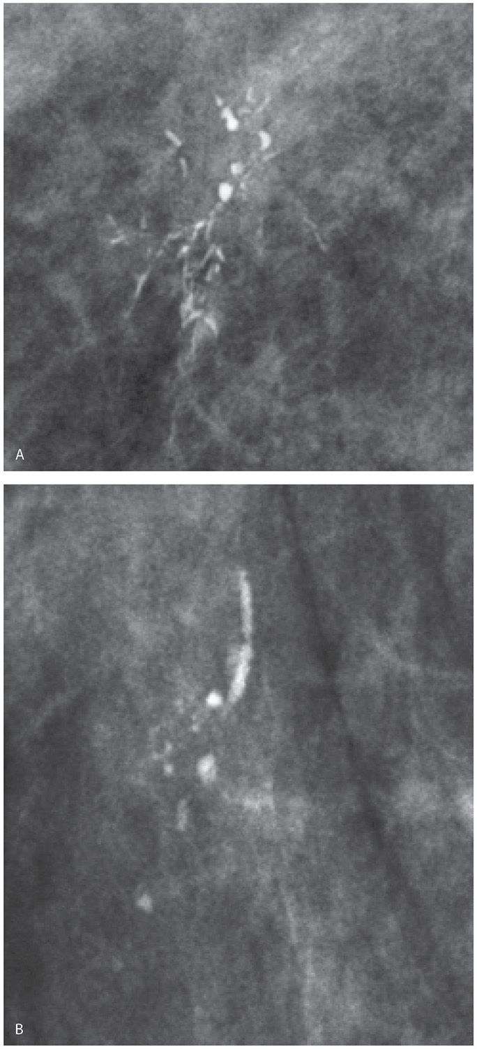
2. Stereotactic core needle biopsy:Returns as DCIS
What would you like to do now?
1. Surgery:
a. Localization
b. Breast conserving surgery with postoperative radiation (no SLNB)
c. (or) Simple mastectomy with sentinel lymph node biopsy +/- reconstruction
Pathology returns as ER/PR + high grade DCIS, what treatment would you recommend?
5 years of anastrozole
Describe Breast Conserving Surgery
1. Preprocedural localization of nonpalpable lesions.
2. Plan incision on lesion depth and location, with consideration of future mastectomy incision.
3. Excise the localized lesion with grossly normal margins. ( 2mm)
4. Orient specimen and send to mammography to ensure the wire, clip, and lesion or calcifications are in the specimen.
5. Palpate the cavity for any suspicious tissue.
6. Ensure hemostasis and close.

Q3 / Breast Ductal Papilloma (Reviewed by KC)
Stem:
Stem: 59y postmenopausal female presenting with complaints of unilateral bloody nipple discharge from the right breast. Mammogram is unremarkable.

What is most likely diagnosis?
Intraductal papilloma
What would you like to do now?
- Ultrasound vs MRI vs contrast ductography: US demonstrated a dilated duct in the right periareolar area
- 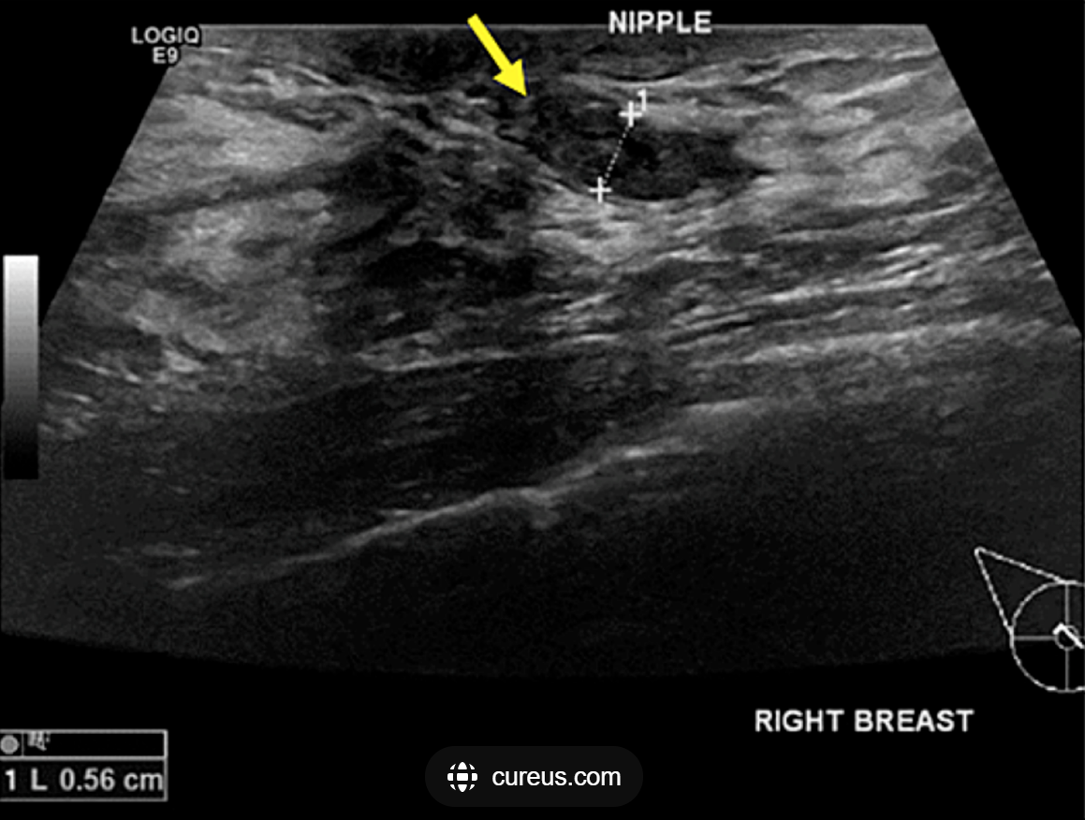
2. Ultrasound guided biopsy: indeterminate
3. OR:
Describe:
- Terminal duct excision/excisional biopsy
- Insert a fine lacrimal duct probe into the dilated duct.
- Make a periareolar incision (no more than 30% circumference
- Isolate the affected duct
- Resect the subareolar region with the abnormal duct attempting to preserve unaffected duct(s) if possible.
4. Pathology: Confirming.

